KeaExpert - User Manual

Version 2.02 August 2025

Contents

1 Version History 3

2 Introduction 3

2.1 Manual Purpose 3

2.2 Nomenclature 3

2.3 An overview of the user interface 4

2.4 Shimming locking and calibrating the magnet 6

2.5 Shimming alternatives 10

2.6 Temperature control and locking the spectrometer 11

2.7 Choosing your first experiment 13

2.7.1 How experimental parameters are chosen and displayed 14

2.7.2 Running your experiment 15

2.8 Running modified versions of previous experiments 16

2.9 Changing comments or deleting previous experiments 16

2.10 The View controls 17

2.10.1 Viewing single plots 17

2.10.2 Cycling between single plots 17

2.10.3 Expand the plots 18

2.11 Post processing controls 18

2.11.1 Changing the cursor mode and zooming 19

2.11.2 Complex data functions 20

2.11.3 Saving and exporting the data 20

2.11.4 1D Data Analyser 21

2.12 1D experiment specific post processing options 23

2.12.1 1D Fourier transform and other post processing steps 23

2.12.2 Phasing complex data sets 27

2.12.3 Calibrating the spectrum 28

2.12.4 Apodization 30

2.12.5 SNR 30

2.12.6 Peak Integration 31

2.12.7 Viewing Stacked plots 33

2.12.8 Processing Stacked plots 36

2.13 Running a 2D experiment – COSY 38

2.14 Default viewing and post-processing options (2D) 39

2.15 2D experiment-specific post-processing options 43

2.15.1 2D Fourier transform and other post processing steps 43

2.15.2 Calibrating the 2D spectrum 44

3 Running multiple experiments using the batch list 46

3.1 Organising the batch list 48

3.1.1 Add experiment 48

3.1.2 Update parameters 48

3.1.3 Delete experiment 48

3.1.4 Copy experiment 49

3.1.5 Rename experiment 49

3.1.6 Move experiment up or down 49

3.2 Selecting samples in the batch list 49

3.3 Adding loops to the batch list 50

3.4 Modifying parameters in loops 51

3.5 Batch timing 52

3.6 Adding items to a batch list while it is running 52

4 Automation using a script 52

4.1 Running a simple script 52

4.2 Adding the script to the main menu 57

4.3 The ArrayedExperiment script 58

5 Getting further help 59

6 Data storage 60

6.1 Date Hierarchy Mode 60

6.2 Flat Mode 60

6.3 Data Folder Format 60

7 Plot layout syntax 61

7.1 Defining plot layout in Experiment scripts 62

7.2 Defining plot layout in automation scripts 62

8 Post processing button layout structures 62

9 Software installation and obtaining a license 63

9.1 Downloading the SpinsolveExpert software 63

9.2 Installation 63

10 Problems running SpinsolveExpert 66

10.1 Missing desktop icon 66

10.2 SpinsolveExpert user interface does not appear 67

10.3 The user interface is unresponsive 68

# Version History

Please refer to the change notes available from the SpinsolveExpert help menu for this list.

# Introduction

The SpinsolveExpert application (or 'Expert'), provides an alternative interface to the normal Spinsolve software provided with the Spinsolve NMR spectrometer. The Expert interface provides the following features, not present in the normal in**t**erface:

* Full access to all pulse program parameters.
* The creation of new pulse programs.
* A fully featured scripting language to control an experiment, and process and save the data.
* User definable post-processing of 1D and 2D data.

The SpinsolveExpert software is built on top of *Prospa*, a general-purpose script-based application which has been used by Magritek for many years to provide different interfaces for its spectrometers. Note that version 2.xx supports the new FX3 based hardware as well as older DSP systems.

## Manual Purpose

The purpose of this manual is to describe how to use the SpinsolveExpert user interface to run existing experiments and process and view the data. Designing new experiments and understanding how the experiments work is described in the Programming manual.

Help for individual menu items can be found in the ‘Menu Help’ option at the top of each main menu (except for the NMR experiment menus).

## Nomenclature

* In this manual the words “folder” and “directory” are used interchangeably
* “Pulse programs” and “experiments” also refer to the same thing.
* A “protocol” is an experiment or a group of experiments which work together to perform some task.
* References to user-interface elements will be in *italics*.
* <application-folder> refers to the folder where the Spinsolve-Expert/Prospa application has been installed.
* <preference-folder> refers to the folder where the Spinsolve-Expert/Prospa user preferences are stored.
* Scripts and macros refer to text based programs run by the Prospa interpreter. The extensions should be .mac or .pex. (macros/Prospa executable)
* ‘us’ means microseconds, ‘ms’ means milliseconds

## An overview of the user interface

|  |  |
| --- | --- |
| After installing the software and getting a license (see appendix D), you can run it by selecting SpinsolveExpert from the Windows Menus or from the desktop short cut. |  |

Assuming you have already acquired a license and have connected to a Spinsolve, then the following window will appear:

In the title bar is the version number of the software and the name and type of the spectrometer you are connected to.

At the middle left of the interface, in the Experiment control section, you can define the *Experiment base-path* for saving collected NMR results, and a comment which will be used to label the experiment folder. Initially these entries are blank:

Data will be stored in a date and time-based folder hierarchy below this base path. To the left of the interface is the history list. This displays all experiments which were performed on the current day. Since no data has been collected this will initially be blank.

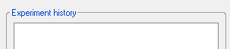

In the center of the interface is the list of parameters for the currently selected experiment. This contains all the parameters relevant to this experiment (although visibility of parameters can be modified). Because no experiment has been added this panel is initially blank.

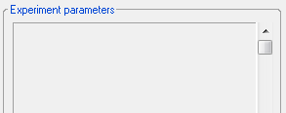

At the top right of the interface is the Progress section which displays the experimental progress, including scan number, time taken and time remaining.

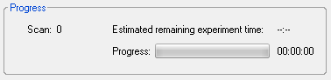

To the right of this is the status section

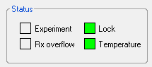

The *Experiment* box displays the status of the system (running, processing and waiting) by modifying the box color, while Rx (*Receiver) overflow* turns red if an overly large signal is detected during the experiment. Before and after an experiment is run, the system NMR lock is checked along with the temperature of the magnet and spectrometer housing. These color-boxes should be green if the system is locked and within temperature specification. If the system is not locked, then refer to the various *Shim* options in the Setup menu. If the temperature indicator is red, then run the *Monitor lock and temperatures* option in the Monitor menu and check if the room temperature is out of the recommended range.

The *View* section provides tools for viewing the displayed data in different ways, both while the experiment is running and when it is finished. This user manual and the help viewer can also be opened at any time using the *Help* button (?)

The Expert Viewer button (top right) will open another instance of Expert which is not connected to the spectrometer, but which allows existing data sets to be loaded and viewed and pulse programs to be editing while the main Expert is running an experiment. The restore button (lower right) can be used to reset the interface if a crash occurs in a sequence. Tool tips may be viewed for each of these buttons to explain their function in more detail (just hover the mouse cursor over a button to see these tips).

The lower right section of the user interface will display experimental data and provide processing capabilities depending on the type of experiment. Initially this is blank.

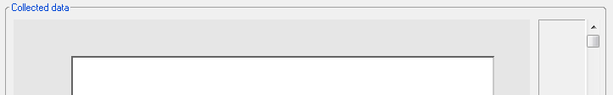

Finally at the bottom of the window is an information bar which displays the experiment status. It is also used to indicate cursor position and data amplitude in the data plots. If the command line interface is selected it will also display command syntax:



More details on all these interface elements will be introduced in subsequent sections.

## Shimming locking and calibrating the magnet

Before any experiments can be run, you will need to ensure the Spinsolve magnet is well shimmed, locked and calibrated. The shimming process improves the homogeneity of the magnetic field, reducing the linewidth of peaks from around 1 kHz to less than 1 Hz. To perform useful spectroscopy, shimming is essential. Calibration is the process of determining the NMR frequency of the various nuclei which will be used. Locking ensures that the system will not drift with time.

First insert a suitable reference sample into the spectrometer, e.g. 95% D20 + 5% H20, and make sure the spectrometer is connected to the computer via the supplied USB cable. It is assumed that the spectrometer has reached operating temperature and that the device driver has been installed correctly. If this is the case, then the spectrometer’s default name and type should now appear in the title bar (refer to the installation guide in Appendix D for device driver installation information).



This reports the serial (SPA) number and the type of spectrometer (a Proton/Carbon 60 in this case with an FX3 processor in this case). There are several options to shim the magnet. You can either import the shim and calibration from the standard software (select *Import Shim and Calibration from Standard Software* in the Setup menu), if you have already shimmed there, or you can select the option *PowerShim* from the Setup menu. For the moment we will assume the latter option is used. In this case the parameters for the *PowerShim* will be displayed:

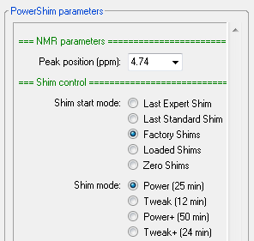

Here you can choose the maximum peak position in the shimmed spectrum (this is used in the calibration step). 4.74 ppm is correct for the water reference, but you can also shim on other samples. Then choose the starting point for the shim. If you are doing this for the first time and the standard software has not been used, then select ‘Factory Shims’ otherwise select 'Last Expert Shim'.

Press the Run button to start the Shimming process:



If you have not selected an experiment base-path then you will be prompted to do so and a suitable path will be suggested. Note that this should be a location that you have read and write access to.

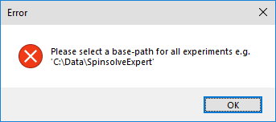

To select this path, press the button labelled “...” in the Experiment control section of the interface:

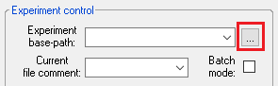

In the next window which appears, choose the option ‘Year\Month\Day’

Navigate to a suitable folder and press OK. The history list title will now change and will look like something like this but showing today’s date:



Then enter a suitable sample name as a comment and press the Run button again.

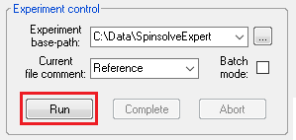

The program will then perform the following steps:

1. The system lock will be stopped if it was already started.
2. The B1 frequency for the magnet will be found. Starting from a default value stored in the spectrometer, the system will search with a 1 MHz and then a 10 kHz bandwidth.
3. Using this frequency, a search will begin to find the optimal set of shims. This is done using the simplex method, first with only the first order shims, then first and second and then first, second and third. For each step, the acquisition bandwidth is reduced in order to increase the measurement resolution.
4. Once the shim is complete the lock is re-engaged.
5. Finally, the B1 frequency is re-found, and the system calibrated.

An example power shim plot is shown below:

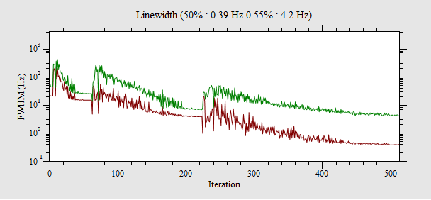

The three search steps mentioned above can be seen in this plot. Note that this shows the linewidth progress for both the 50% linewidth (full width half maximum) and 0.55% linewidth. The time required for the power shim will be between 25 and 30 minutes. While the experiment is running the progress bar will indicate how much longer the experiment will take.

With a successful completion of the PowerShim a parameter file containing the shim values will be stored in the preferences folder in this location

<preferences_folder>\SpinsolveParameters\Shim

You can access this folder via the ‘Open preferences’ option in the main File menu.

Also the history list will now contains a new entry, which corresponds to a folder that stores the parameter and shim history recorded during this process.

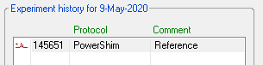

The history entry will contain the time stamp of the experiment (format: hhmmss), the protocol name – in this case PowerShim and the comment you added: 'Reference' in this case. The history list will also be labelled at the top with the current date.

The small icon on the left indicates that there is an acquisition parameter file present (the dot) and recorded data (the spectrum). A second dot – not present in this case, indicates that the folder contains exportable binary data (e.g. for MestraNova)

Note that only experiments performed on the current day will be displayed, however older data sets can be found by navigating to the corresponding day by pressing on one of the buttons below the history list to change the day, month or year.



If you press past the current date (for example, by pressing Year+) it will stop at the current day.

## Shimming alternatives

As mentioned above, if you have a good shim from the Standard software, you can import this shim using the ‘*Import Shim and Calibration from Standard Software*’ option in the Setup menu. Remember to press the ‘Run’ button after selecting this option.

|  |  |
| --- | --- |
| If your shim is quite good, but not perfect, you can run the *QuickShim* protocol, also found in the *Setup* menu. This uses a faster shim algorithm and can take less than a minute to complete depending on the options you choose. The options here are similar to *PowerShim*, except that you can choose which shims to optimise. Often the ‘Fast’ option will do the job, and this only takes about 40 seconds if the 1st order and z2 option is chosen. In this case it is not necessary to lock and calibrate if these are already correct. |  |

Note that the progress bar will typically indicate the shortest required time, and if the shim is poor, or you are shimming with a sample with overlapping lines the shimming process may take two or three times longer than expected. A fast power shim option is also available in the Scripts menu. This combines a limited power shim followed by an all-shim Quickshim and takes around 13 minutes to complete with similar results to the normal much longer power shim.

## Temperature control and locking the spectrometer

Because the NMR frequency is dependent on the magnet temperature, it is necessary to control the temperature of the magnet. The Spinsolve magnet and housing temperature is controlled by a set of fans and Peltiers. For the housing (box), this is set to 26 °C, while the magnet is 28.50 ± 0.01 °C for 43 MHz and 26.50 °C for higher frequencies. You can monitor the temperature of different parts of the spectrometer by running the ‘*Monitor lock and temperatures*’ experiment in the Monitor menu. Once the option has been selected from the menu, the parameters will appear in the parameter section of the interface and then you can start the experiment by pressing the *Run* button. In this case you can choose the number of measurements to perform. You can also stop the experiment using the *Abort* or *Complete* buttons.

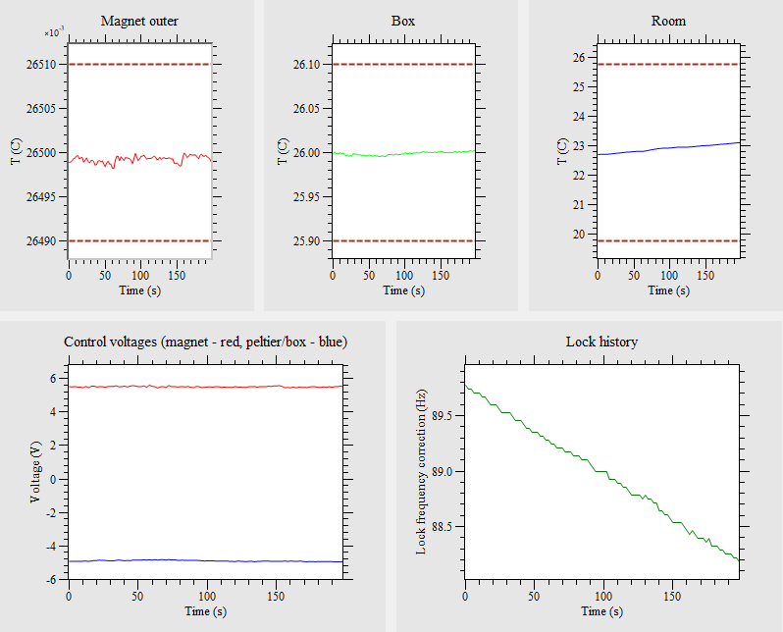

*The output of the temperature monitor showing the temperature history of the magnet, spectrometer box and room.*

A typical result after running the temperature monitor is shown in the previous figure. The dotted brown lines represent the temperature limits. Note that room temperatures significantly above 25.5 °C or below 19.5 °C (in this example) may cause the temperature control to fail. High temperatures should be especially avoided, as this can cause excessive condensation inside the box. In some cases, high temperatures may cause the spectrometer to shut down to prevent this from happening (this depends on the installed firmware version). The power supply voltages for the magnet heater and Peltier cooling unit are displayed in the lower left plot, while the lock offset history is also shown in the lower right.

When the temperature is controlled correctly, the frequency stability will be approximately ±100 Hz. However, this is not good enough for NMR signal averaging and so in addition we provide a Fluorine NMR lock integrated into the probe. If you don't have the lock activated, then signal averaging will probably not be possible because of residual temperature and, therefore frequency drift. To activate the lock, run the option ‘*Lock and Calibrate*’ from the *Setup* menu (this step will have been done automatically using the *PowerShim* or *QuickShim* protocols). Finding the lock is done in several steps. First a series of simple pulse and collect experiments is used to determine the lock frequency. The experiment then moves over to the independent lock controller which repeats this experiment periodically, using the measured frequency to correct the field via an offset coil on the magnet. You can monitor the lock at any time between running other experiments by using the *"Monitor lock signal"* command in the *Setup* menu.

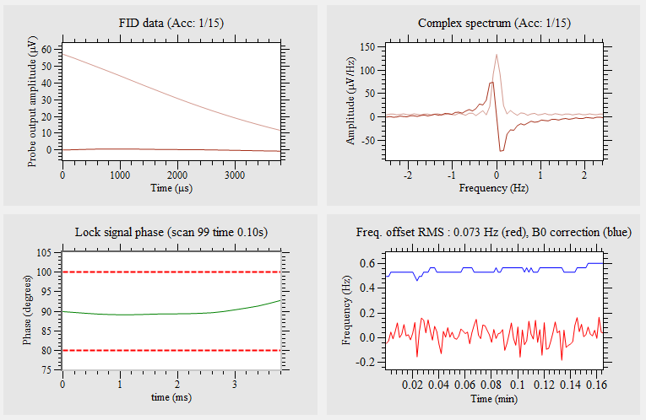

*The output of the Monitor lock signal protocol*

This should show two traces in the lower right plot. The red trace shows the NMR frequency variation after correction, while the blue trace shows the control offset (as a frequency). If the magnet changes temperature, the blue line will deviate away from the (hopefully) constant red line. As shown above, this information is also displayed with the temperature monitor. Note that the offset coil can only correct +-2 kHz of drift – beyond this the lock will be lost and will need to be refound.

Also note that the magnet should be shimmed before locking can be successfully activated. Once locked, recalibration is also necessary. All the experiments in the Setup menu include the necessary steps.

## Choosing your first experiment

Once the system is shimmed and locked you can start running experiments. All you need to do is replace the reference sample with something more interesting and choose which experiment to run.

The available experiments for your spectrometer can be found in the main menu between the first two vertical bars.



In this case the Proton and Carbon experiment menus have been loaded since this is a dual channel spectrometer. Other experiments and experiment menus can be added later – see section 4.2.

From this menu list choose the Proton experiment (a simple pulse and collect experiment). This will load the Proton parameters into the experimental parameter list.

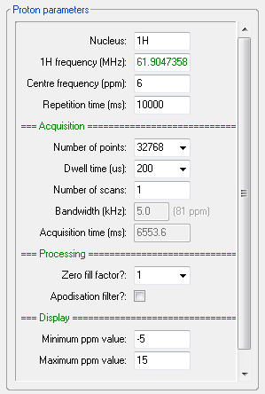

*The Proton parameters (the minimum list)*

Items in the list which are coloured green are common parameters (see next section) and cannot be modified.

### How experimental parameters are chosen and displayed

SpinsolveExpert gives you a lot of control over the experimental parameters. However, even if you are an expert user, it makes sense to provide a set of parameters which will work most of the time. This is achieved using the following process:

1. A set of default parameters are stored with each experiment pulse program. These are loaded into the parameter controls first.
2. Parameters which are spectrometer specific are loaded next. Examples are the Proton 90-degree pulse amplitude and duration. This information is stored on the Spectrometer and can be viewed in the File menu; option ‘*Open Spinsolve parameter dialog*’.
3. Finally, the parameters which are dependent on environmental conditions (the so-called common parameters) are loaded. Normally this is just the NMR frequencies. These will have been generated using the various calibration experiments found in the *Setup* menu.

By default, not all parameters are displayed, initially just the ones you most likely need. However, you can choose to display a different range of parameters using the relevant options at the bottom of the *Experiment* menu (‘*Show minimum/all/user defined parameter entries*’). User defined parameters are set using the ‘*Edit parameter visibility*’ option.

### Running your experiment

Choose a suitable comment for your experiment (typically the sample name) and press the *Run* button. Note that the comment will be part of the folder name and so should follow Windows naming rules. Before running the experiment, the common parameters will be updated in case they have changed since they were originally defined (the case in batch mode especially).

After a few seconds the experimental results will appear in the graph region to the right of the interface:

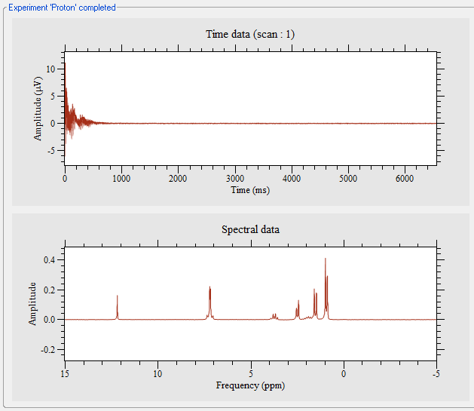



Also, the history entry will be updated with the latest result

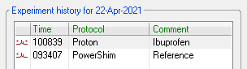

To emphasise the importance of shimming, here is the result of the same experiment with all the shim values zeroed. Notice the expanded scale. The FWHM linewidth is about 500 Hz.



*The unshimmed Ibuprofen spectrum*

## Running modified versions of previous experiments

If you have run an experiment, but wish to change just one or two few parameters, you don’t need to start from scratch by selecting the experiment from the menu. Instead, just select the previously run experiment from the history list, modify the relevant parameters and run it again. Note that apart from common parameters like frequencies, the previous experiment parameters and data will not be modified, unless you modify them manually. This option takes the place of the experiment numbers available in previous versions of SpinsolveExpert.

Once an experiment has completed, data will be saved in the history folder. This will be reloaded the next time the experiment is selected from the history list. The plot layout can be different when loading data as opposed to running an experiment, as some of the plots generated while running an experiment just contain intermediate results.

## Changing comments or deleting previous experiments

By default, it is only possible to remove previously run experimental results from the SpinsolveExpert user interface if data was not collected. This will happen if the abort button was pressed part way through the experiment. In this case the experiment folder can be moved to the trash, by selecting the experiment(s) in the history list and then right clicking and choosing the option ‘Remove incomplete entry’. The only parameter which can be modified on existing experiments is the comment which appears in the file name and in the history list. Again, this can be changed using the history list contextual menu. You can also view the experiment folder in a Windows Explorer dialog using this menu. A list of predefined comments can be entered using the Samples menu. (See section 3.3).

If you are less concerned about the longevity of your data (for example while developing a new sequence), it is possible to relax this restriction. Please see the ‘General’ button in the SpinsolveExpert preferences dialog accessible from the main menu. (See section xxx)

## The View controls

During the experiment, or when it is completed, you can use the View controls to see the plots in more detail:

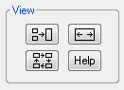

Following is a description of these controls:

### Viewing single plots

If the plot layout contains multiple plots and you wish to only view one of them, then select the desired plot by clicking on it (it will become indented), and then press the *View only the current plot* button (hover over the button to see tooltips):



The button icon will then change so you can revert to the multi-plot view by clicking it again.



### Cycling between single plots



This has the same function as ‘Viewing single plots’, but in addition it will step between the individual plots each time you click this button.

### Expand the plots



This will maximise the size of the plot regions, temporarily hiding the experiment and parameter controls. The CLI (command line interface) is still present, but moves to the top left of the main window. Once the plot interface has been maximised, the button icon changes allowing the plots to revert to their previous positions.



## Post processing controls

Once an experiment has been completed, post processing controls will be available to right of the plots. Some of these controls are the default for the current type of plotted data (i.e. 1D or 2D), while others are user definable. A short horizontal line divides the two types of control.

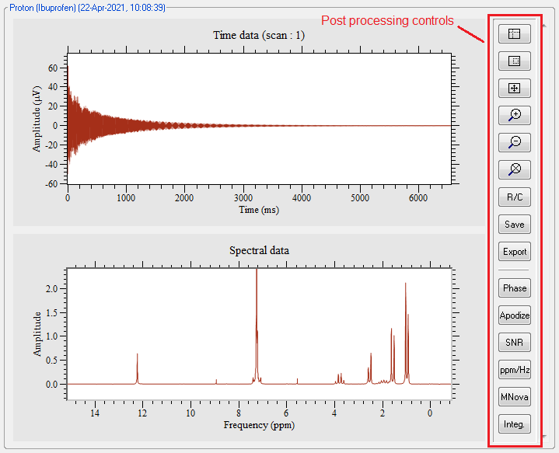

Different controls will appear depending on the experiment and plot selected.

Following is a description of the default 1D controls. These will be applied to the current plot (the one with an indented border).

### Changing the cursor mode and zooming

Within a plot, data points can be interrogated by selecting the *Data point location* button:



This generates a cross-hair cursor which can be moved over the plot trace. Two cursors will be displayed if complex data is visible. The cursor position within the data set, along with the amplitude, will be reported in the main window status bar. Clicking the right mouse button while the left is depressed, will set the selected point to zero, so linewidth and peak separations can be measured. Press the right button again to revert to the normal display. When in offset mode an 'O' will appear in the extreme right of the main window status bar.

The *select region* button allows zooming:



After pressing this button, you can select a rectangular region in the plot which can subsequently be zoomed using the Ctrl+Z keyboard shortcut. Alternatively, a region can be selected and zoomed in one step by holding down the Control key as the region is dragged. This option also works in the cursor and drag modes. When in zoom mode a 'Z' will appear in the extreme right of the main window status bar.

Once a region has been zoomed you can move to the last region selected by pressing Ctrl+L (Last) or display the *complete* data set by typing Ctrl+A (All). All of these short-cuts can be found in the View menu.

Once a region has been zoomed you can move around the plot using the drag button



In this mode left-click and move the mouse to drag the plot.

In all cursor modes zooming and panning can also be performed using the mouse scroll wheel and the arrow keys (with control/shift key modifiers).



A selected region can be zoomed using this button.



The previously viewed region before zooming can be retrieved using this button.



This will display all the data, unless a spectrum is selected and minimum and maximum ppm values are present in the parameter list, in which case the zoom range will be restricted to these limits. To force all data to be displayed, type Ctrl-A when the plot is selected.

### Complex data functions

If the data has been collected in complex mode, then you can display the real/imaginary or complex data by clicking the *R/C* button



If the data is real this button will do nothing.

### Saving and exporting the data



Any changes you make to the current plot will only be recorded if you press the Save button. Note that only the view of the raw FID data will be modified, not the original data.



By default, data is saved in a proprietary Prospa format (*.pt1 for 1D files). If you wish to export the data to another program, you can use the Export button. This displays a dialog box in which you can choose a simple Prospa binary or ASCII (text) format for the output file.

This defaults to saving data in the current experiment folder (which can be viewed using the *Open current data folder* option in the File menu). However, you can choose a different folder if desired. The formats used here are explained in detail in the help documentation.

Note that from V1.10 onwards most experiments also store a .1d file for use with MNova, but this behaviour can be forced by checking the ‘Data files’ option in the ‘Saving Experiments’ page of the SpinsolveExpert preferences dialog accessible from the main menu.

### 1D Data Analyser



*Note this tool is still in development.*

This option will copy the contents of the current 1D plot into a new window which has additional processing capabilities. These can be summarised as follows:

For individual spectra:

* Comparison of spectra by overlaying and adjusting the x position and y height.

If spectra are loaded from the history list and then this option is selected, then each spectrum will be displayed over the top of the previous one. Alternatively, adjacent spectra in the history list may be selected (shift-click) and then the option ‘Analyse data set(s)’ selected from the history list contextual menu.

The ‘Move horizontal trace’ toolbar option show here:



will allow the selected trace to be moved horizontally by left-clicking the mouse and dragging. Deselect the toolbar option to exit this mode.

The ‘Scale trace vertically’ toolbar option show here:



will allow the selected trace to be scaled vertically by rolling the mouse wheel. Deselect the toolbar option to exit this mode.

For stacked plots:

* Phasing of all or individual traces.

The currently selected trace will be phase-able if this option is selected:



The same phase shift will be applied to all traces in the stacked plot if this option is selected:



Integration and fitting of data to a model curve.

Here is an example of integral fitting for a T2 data set:

For more information, please check the help menu in the Data Analyser.

## 1D experiment specific post processing options

All 1D experiments will include the post-processing and viewing options described above. However, each experiment can also have experiment-specific options. These can also be different for each plot. As you select a plot, the experiment-specific processing options for this plot will be displayed. Those applicable to the Proton experiment are described below. At the end of each section are the lines of information you need to add to the post-processing layout structure to get these buttons to appear. Please modify the plot numbers to match your plot layout. (Refer to the 'Proton' experiment 'User Interface' tab for an example).

### 1D Fourier transform and other post processing steps



This allows reprocessing of collected 1D time domain data. This includes apodization, deconvolution, Fourier transform, phasing and baseline correction. The interface will initially be populated by the proc.par file generated by the experiment script.

You can retransform the data using the *Transform* button.

If autophasing has been performed, the p0 phase value chosen will appear in the phasing section. Any changes made to the phase using the phasing tool will be applied to these fields so they will be reapplied the next time the data is transformed. Note that phasing can be applied using the up-down controls or using the sliders which appear when the phase button is pressed. (Note that the shift and alt keys can be used to change the steps size in the updown controls to 10 or 0.1 degrees/ppm).

The spectral linewidth can be improved using the deconvolution feature. After collecting the FID from a reference water sample, note the dwell time and number of points. Then after running your more complex sample, using the *same* dwell time and number of points as the water reference, choose the *Reference fid* option from the Deconvolution method drop down menu.

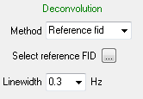

Select the file ‘data.1d’ from the reference water sample folder using the button labelled '...' and then press the Transform button. Spectra with and without reference deconvolution applied are shown below:

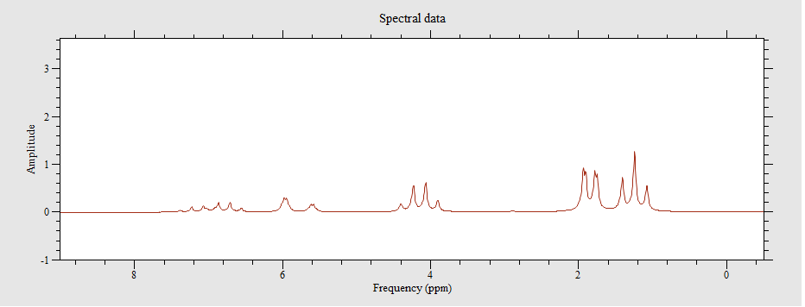

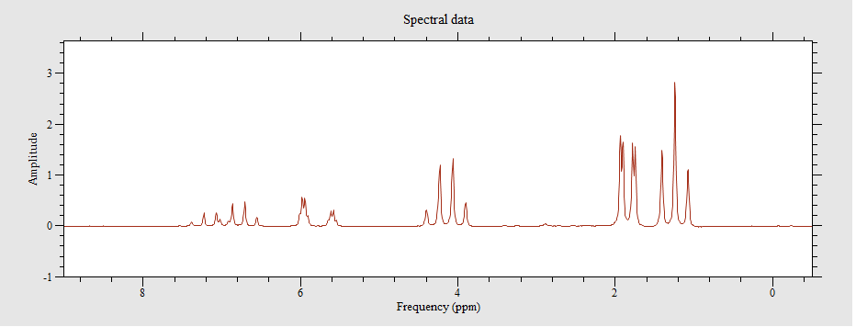

If you observe baseline offsets you can correct them with the Offset or Segment options in the baseline correction section.

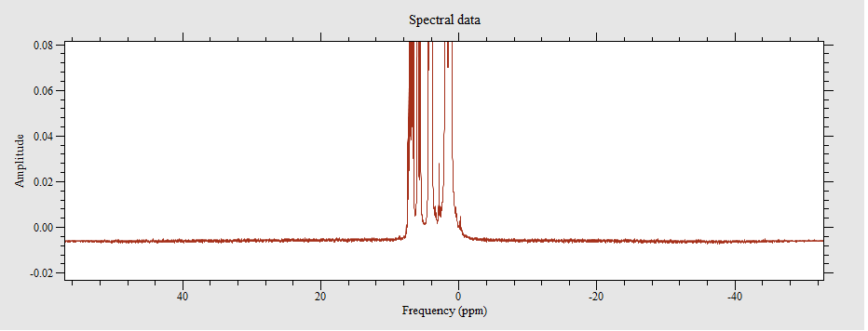

*A spectrum showing baseline offset*

The offset option just subtracts the average of the spectral end regions while the segment option is more appropriate for baseline rolls

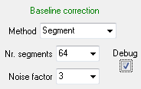

Initially use the above parameters to observe the baseline (the green line) and the fit (the blue line).

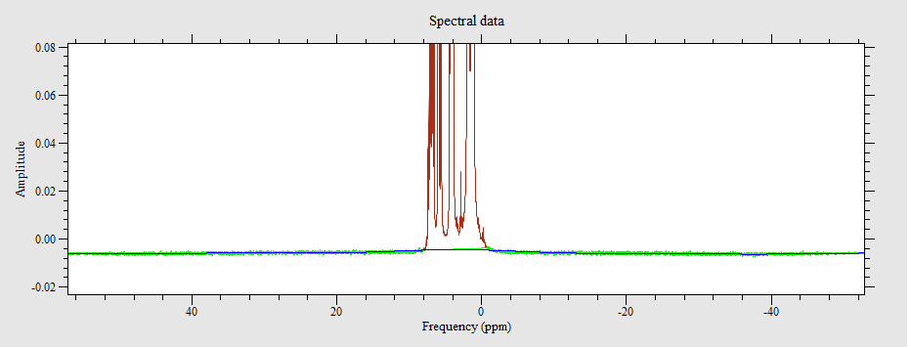

If the fit looks reasonable remove the debug option and reapply:

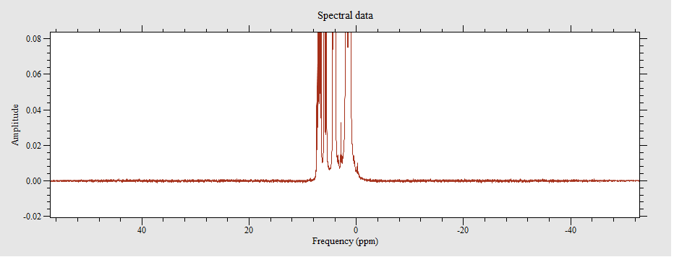

Processing parameters generated using the FT dialog are stored in a temporary file called proc_temp.par. This will be copied to proc.par when the post processing *Save* button is pressed or if prompted to do so when changing experiments or leaving the program with unsaved changes.

*Post processing layout command:*

In the User Interface tab of the pulse program editor and compiler is a procedure called processing_controls. This includes a layout 2D structure which consists of a group of parameters which define each post processing button. In the follow example we see the “FT” button which is applied to the pt1 plot (the top one containing the FID). When pressed this button will cause the apodizeNTransform macro to be run. It passes the two plot names to this macro. Note the escaped quotes – these are required because the macro name is already quoted.

layout = struct(...;

buttonLabel = "FT",

plotName = "pt1",

macroToRun = "apodizeNTransform(\"pt1\",\"pt2\")";

...)

For more information on writing post processing macros, see section xxx

### Phasing complex data sets

Some complex data sets can be phase corrected using the *Phase* button.



This displays the dialog window shown below:

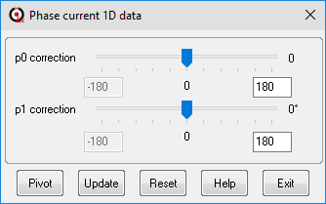

Use the slider controls to adjust the phase values. While the slider is selected use the mouse scroll wheel for fine control - Use the Pivot button when applying the first order phase correction. This allows a peak to be selected which will have zero first order phase correction applied. If the phase limits are too large or small, they can be modified by entering a new value (in degrees) into the text boxes provided and pressing enter. This will update the slider range. Click on the Help button for more details on how to use these options. Note that the phase option works on *real* data as well as complex. In the former case a Hilbert transform is applied (if the data is a power of 2 in length) to regenerate the imaginary part of the data set.

A more complex version of this dialog appears for certain data sets which permit reprocessing (e.g. Proton).

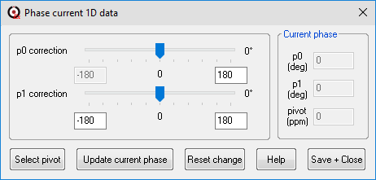

This includes the current phase as recorded in the proc.par file (processing parameters). This allows multiple manual phasing attempts to be accumulated so that next time the data is processed the combined phase will be applied. Press the Help button to get more information.

*Post processing layout command:*

Here is the post processing layout command for the Phase button:

layout = struct(...;

buttonLabel = "Phase",

plotName = "pt2",

macroToRun = "manualPhase1DSpecial()";

...)

### Calibrating the spectrum

The x-axis of spectra can be displayed in either Hertz or PPM by pressing the button labelled with *ppm/Hz*. This will use the B1 proton (or other) frequency to perform the rescaling.



The button label will then be toggled depending on the current display mode.

*Post processing layout command:*

Here is the post processing layout command for the ppm/Hz button:

layout = struct(...;

buttonLabel = "ppm/Hz",

plotName = "pt2",

macroToRun = "togglePPM_Hz(1)";

...)

While in PPM mode the axis offset can be calibrated by pressing the *Calibrate (or Set Reference)* button



This forces the plot to display PPM and then opens a small dialog which accepts the frequency (in PPM) of a reference peak. Once you have entered this value press the *Select peak to calibrate* button and select the peak with the mouse and cursor.

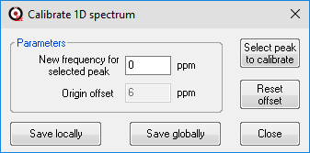

Press the *Save locally* button to only modify the proc.par file for this experiment (typical if using this as part of a post processing procedure) or *Save globally* to save the result to proc.par and to modify the B1 frequency for the current nucleus (as stored in the common parameter file). In this case this frequency will be applied to all future experiments.

Press the *Reset offset* button to zero the center frequency. Note that typically you will not need to use this option as the spectrum is automatically calibrated after a shim or 'lock and calibrate' script. Also, the Save globally option only affects the current B1 frequency not other nuclei, so if you have a multi-nuclear system, you should use the calibrate options in the Setup menu.

*Post processing layout command:*

Here is the post processing layout command for the Calib. button:

layout = struct(...;

buttonLabel = "Calib.",

plotName = "pt2",

macroToRun = "calibrateXAxis()";

...)

### Apodization



Using this option spectra can be apodized to improve SNR or enhance resolution. This button will display a dialog which includes several predefined apodization filters which can be applied to the time domain data. A Fourier transform is then applied to display the result in the current window. The filter parameters can be adjusted in real time if the data set it not too large.

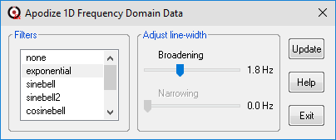

Select the Help button for details on how to use this option.

*Post processing layout command:*

Here is the post processing layout command for the Apodize button:

layout = struct(...;

buttonLabel = "Apodize",

plotName = "pt2",

macroToRun = "apodizeFreq()";

...)

### SNR



The SNR button will report the Signal-to-Noise ratio of spectra (or FIDs) in the command line interface. In both cases the peak signal is divided by the twice the RMS of measured at the end(s) of the data set. For this reason, it is important that the latter region has a flat baseline, otherwise incorrect results will be returned.

*Post processing layout command:*

Here is the post processing layout command for the SNR button:

layout = struct(...;

buttonLabel = "SNR",

plotName = "pt1",

macroToRun = "snrSpectrum()";

...)

### Peak Integration



This displays a peak-picking and integration interface.

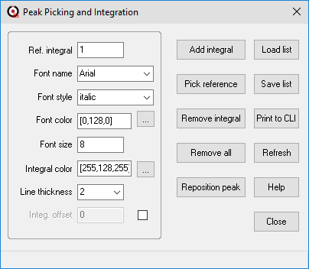

To add integral regions and pick peaks, select the *Add integral* button and click on either side of a peak, covering the complete width of the peak. Repeat this process for all isolated peaks.

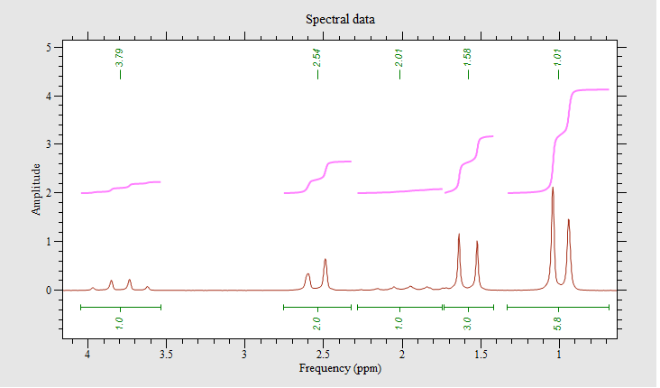

The peak position is determined by the average value of the region selected, while the integral is calculated from the sum of all data between the selected points. The peak position is displayed at the top of the screen and the integral at the bottom.

The colors and fonts used can be adjusted in the user interface.

To reference an integral, select the reference value (1 in this example) and click on the reference peak. All integral values will be scaled to this reference value.

Peak integrals can be recalculated by using the *Add Integral* button and then selecting over the top of an existing peak, while the peak position can be modified independently of the integral range by using the *Reposition Peak* button.

Instructions for the user are displayed in the status bar at the bottom of the window.

You can list the peak integrals found by pressing the *Print to CLI* button and also save/load, to/from a local peak list file using the *Load/Save list* options.

Position (ppm) Left (ppm) Right (ppm) Integral

1.007 0.683 1.330 6.000

1.576 1.419 1.733 3.091

2.014 1.743 2.285 0.990

2.539 2.324 2.754 2.037

3.793 3.538 4.048 1.026

5.544 5.262 5.825 0.070

12.234 12.051 12.417 1.009

This information is stored in the current data folder.

*Post processing layout command:*

Here is the post processing layout command for the Integ. button:

layout = struct(...;

buttonLabel = "Integ.",

plotName = "pt2",

macroToRun = "PeakIntegration(\"pt2\")";

...)

### Viewing Stacked plots



When stacked plots are displayed in a plot then this post processing button can be displayed when the plot is selected.

Pressing this button will display the following dialog:

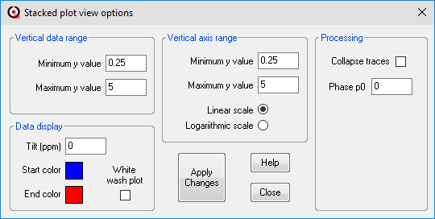

The function of each parameter/control is listed below:

*Vertical data range*

Minimum/maximum y value ... these values describe the range of axes values that the row data spans. (e.g., this might be the range of T1 delays values in the T1-IR data set). These values will modify which rows are displayed in the plot and the spacing between them, but the axis will remain unchanged.

*Vertical axis range*

Minimum/maximum y value ... these values describe the display range on the vertical axis. This will affect the position of the displayed data on the vertical axis and can be used as a vertical zoom.

*Linear/logarithmic scale.*

Defines how the data is mapped to the vertical axis. e.g., if T1-IR data is collected using logarithmically spaced delay values, then the logarithmic option should be chosen. This does not affect the displayed data, just the vertical axis.

*Tilt (ppm)*

By default, each row of stacked plot data is aligned with the frequency scale. The tilt option will displace each row, so the top row is offset by the amount specified in the tilt parameter. Note that this only applies to the current zoom.

*White wash plot*

By default, each row of the stacked plot data shows any data from other rows over the top of it. This can give rise to a very confused plot, especially if displayed row amplitudes are increased. The white-wash mode displays the rows from the top to the bottom with each row 'white washing' all points below the row. In this way it appears as if the lower rows are in front of the top rows.

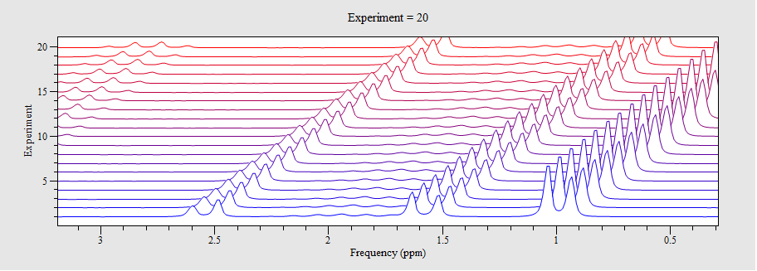

*A reaction monitoring stacked plot showing tilting and white-wash mode*

*Start/End color*

Clicking on these colored boxes allows the color scale used to display the stacked plot to be changed. The rows of the stacked plot are drawn in colors which varies linearly from the start color at the bottom of the plot to the end color at the top of the plot.

*Collapse traces*

This will make the *Vertical data range* almost zero so you can overlap the traces. This is useful if looking for differences. Note that the range must not be exactly zero otherwise you can’t undo this function correctly.

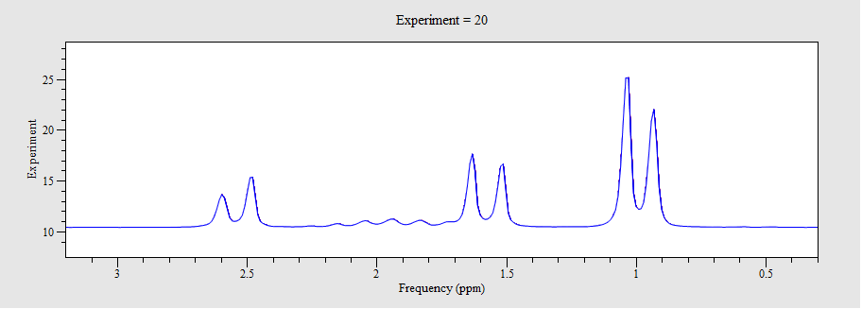*All traces collapsed (and tilt reset to 0)*

*Phase p0*

This will apply a zeroth order phase correction to each row in the stacked plot. You can work out the correct phase by selected one row and then the option ‘Copy current trace to a new 1D window’ using the contextual menu (press the right mouse button). In the new 1D plot you can phase the data using the phasing tool (Ctrl+Shift+P) and then use this value to correct all rows in the stacked plot. (Note that there are also phasing tools in the 1D Plot Analyzer interface).

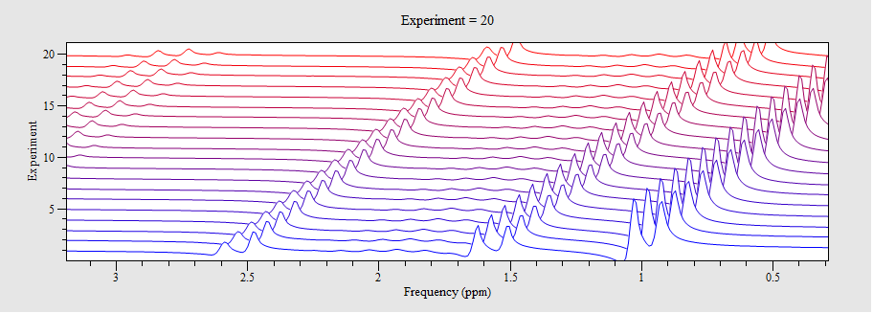

*A phase shift of 45 degrees applied to all stacked plot traces*

*A note on zooming into Stacked plots*

The mouse-based zoom only horizontally enlarges the stacked plots. The vertical extent will just scale the amplitude of the peaks. Use the *Vertical axis range* option to zoom stacked plots vertically.

*Post processing layout command:*

Here is the post processing layout command for the Stacked plot. button:

layout = struct(...;

buttonLabel = "View",

plotName = "pt1”,

macroToRun = "StackedPlotSetup()";

...)

### Processing Stacked plots

|  |  |
| --- | --- |
| The T1 and T2 experiments provide interactive integration and curve fitting even while running the experiment. The script used is called IntegrateRegions. In this case the interface is not a separate window but a series of post processing buttons.  The first button allows you to hide the FID and individual spectra, while the second button allows a peak to be integrated. To integrate a peak, press the *add integrate peak* button (the second down) and then click both sides of the peak in the stacked plot. The integral will be displayed in the second plot and if enough points are present a T1 or T2 value will also be displayed. |  |

You can add or remove peaks at any time, and the lower plot will be updated. The *Clear* button removes all integrals and allows you to start again while the bottom button allows the stacked plot view to be modified (this is only active when the experiment is finished).

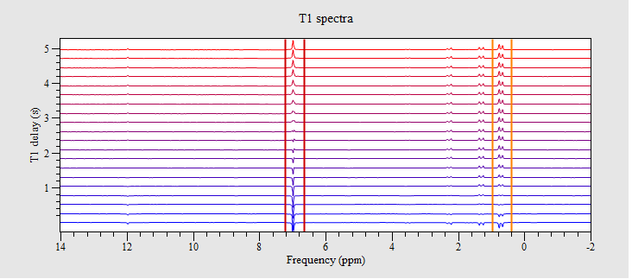

*A T1-IR experiment output as a stacked plot with two peaks selected*

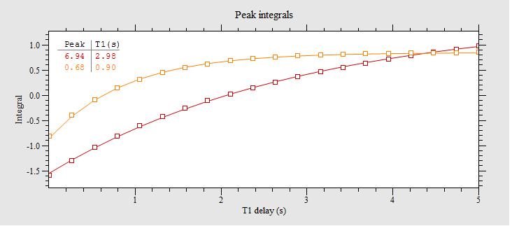*The integrals of these two peaks along with an inversion recovery fit and T1 parameter*

If you click on the lower plot, you will see different buttons



Again, the first button allows the plots to be rearranged for ease of access. The second button clears all the integral information from the plots so you can start fresh, while the final button prints the integral information to the command line interface:

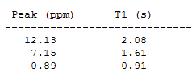

A similar interface is supplied for the PGSE and PGSTE experiments in the Diffusion menu.

*Post processing layout command:*

Here is the post processing layout command for stacked plot processing:

layout = struct(buttonLabel = "Toggle",

plotName = "pt3",

macroToRun = "IntegrateRegions:TogglePlotsDisplayed()",

iconFile = "FourToTwo.png",

active = "true",

toolTip = "Toggle between 4 and 2 plots.";

buttonLabel = "Integ.",

plotName = "pt3",

macroToRun = "IntegrateRegions:AddIntegral(\"T1IR\")",

iconFile = "AddIntegral.png",

active = "true",

toolTip = "Select a region in the stacked plot for integration.";

buttonLabel = "Rm Int",

plotName = "pt3",

macroToRun = "IntegrateRegions:RemoveIntegral(\"T1IR\")",

iconFile = "RemoveIntegral.png",

active = "true",

toolTip = "Select an integral in the stacked plot for removal.";

buttonLabel = "Clear",

plotName = "pt4",

macroToRun = "IntegrateRegions:ClearIntegrals()",

iconFile = "ClearIntegrals.png",

active = "true",

toolTip = "Remove all integrals.";

buttonLabel = "Print",

plotName = "pt4",

macroToRun = "IntegrateRegions:PrintIntegrals(\"T1IR\")",

iconFile = "PrintIntegrals.png",

active = "true",

toolTip = "Print all integral results to the CLI.";

buttonLabel = "View",

plotName = "pt3",

macroToRun = "StackedPlotSetup()",

iconFile = "stacked_plot_view.png",

toolTip = "Modify the stacked plot view.")

Note that duplicate items (for display in more than one plot), have been removed for brevity.

## Running a 2D experiment – COSY

Multi-dimensional experiments can also be run, displayed, and processed using the SpinsolveExpert software. The simplest of these is the COSY experiment. Select this from the Proton menu.

Once started, the experiment proceeds by performing dummy scans to reach equilibrium, and then collects a number of FIDs with different evolution times. Each FID is recorded and displayed as a single row in the raw data 2D plot. At the same time the final spectrum is calculated and displayed. As more rows (i.e., different evolution times) are collected the spectrum will slowly become better defined along the vertical axis.

|  |  |
| --- | --- |
| *After 10% of evolution time data collected* | *After all evolution time data collected* |

## Default viewing and post-processing options (2D)

The cursor, viewing, save and export options are the same for 2D data sets as they are for 1D, however the 3 remaining default controls are different. These are described below:



This button toggles the display of a colour-scale next to the current 2D plot.



This displays a dialog which allows the intensity scale to be modified interactively and contours to be plotted. The colour-scale can also be changed.

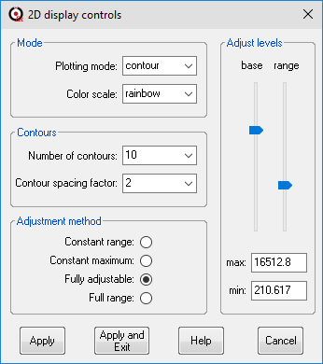

There are two main display options. With time domain data 2D plots are displayed in *intensity* mode with *linear* mapping. This means that a data point with twice the amplitude will be twice as bright if a grey color scale is used to display data. On the other hand, spectra are typically plotted using contours and, in this case, a logarithmic (log) mapping is preferred as it shows both weak and strong peaks at the same time without the need to adjust the colour-scale. To select log mapping choose one of the non-linear spacing factors in the Contour spacing factor text-menu.

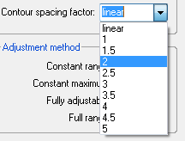

Note that these factors relate only to contour plotting and will make no difference in the intensity display – all factors result in a log mapping.

Other options in the *2D display controls* window allow different color-scales to be chosen and different numbers of contours to be displayed. There are several positive and bipolar color-scales available. New ones can be added as required. Please refer to the Prospa documentation to see how to do this.

The *base* and *range* sliders will be enabled depending on the *Adjustment method* and enable the data contrast to be optimised.

Generally, you will not need to use the level adjustments in this dialog as the Mouse scroll wheel can use to control the contour in a frequency domain plot. By default, this adjusts the minimum contour level. Holding down the shift key at the same time adjusts the maximum contour level.



This displays a dialog which allows a 2D plots to be investigated in more detail:

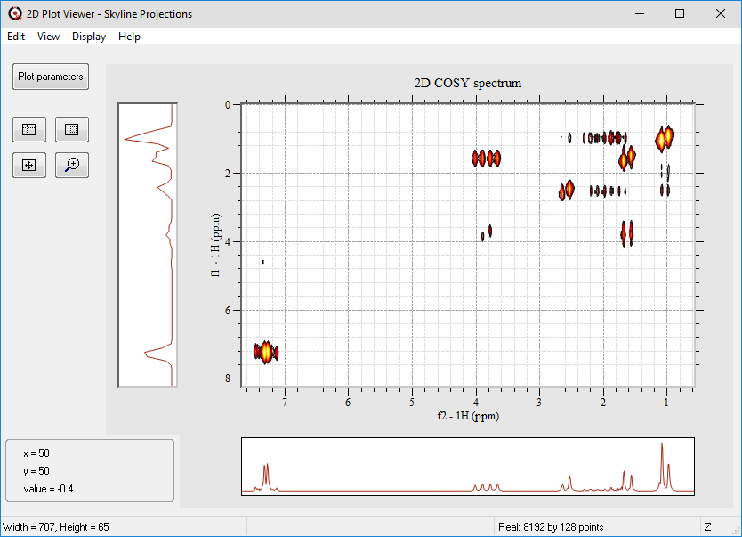

By default, this displays sum projections for rows and columns. Other options are skyline projections (showing the maximum values) and general row and column view. Pilot scans can also be displayed if present.

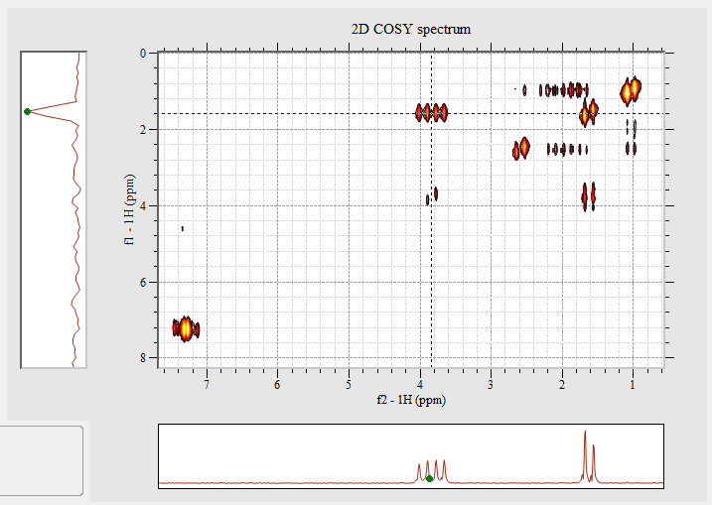

You can look at the 1D plot in more detail by selecting the contextual menu option *Copy trace data to new 1D window* option found in the 1D plot windows.

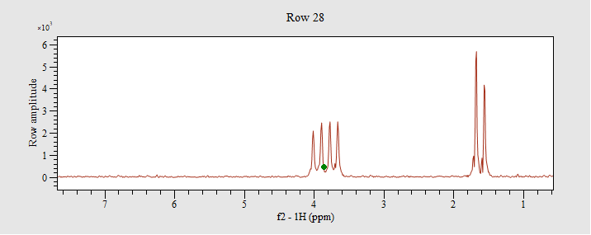

This gives a range of display and analysis options (see general Prospa help for more details). A similar option is available for 2D plots.

The final option in the waterfall plot which shows a 3D representation of the spectrum.

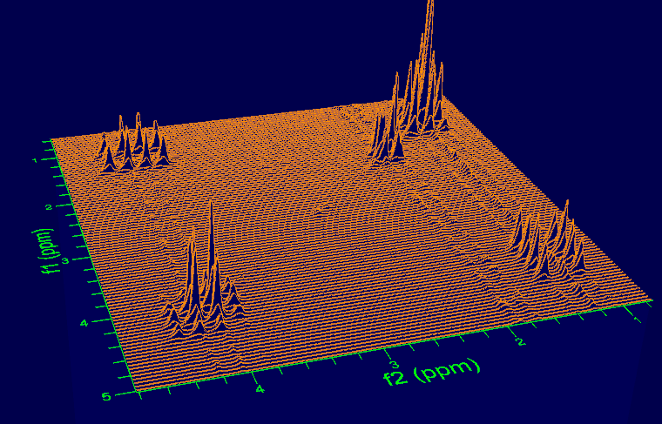

*Image displayed as a waterfall plot*

The viewing angle can me modified by using the mouse and shift keys while the peak amplitudes can be adjusted using the shift key in combination with the up/down arrow keys. Viewing distance is controlled with the mouse scroll wheel. Please refer to the Help information for more details on manipulating this graph.

## 2D experiment-specific post-processing options

### 2D Fourier transform and other post processing steps

This allows reprocessing of collected 2D time-domain data. This includes apodization, deconvolution, Fourier transform, phasing and baseline correction for each dimension. The interface will initially be populated by the proc.par file as generated by the pulse sequence.

This interface works in a very similar way to the 1D version, with each tab referring to a different dimension. (f2 is horizontal and f1 vertical). The only difference is that the only baseline correction available is a simple offset rather than a baseline search and trig fit, and reference deconvolution can only be applied to the first dimension.

The third tab (other) contains functions which are applied to the data processed by the first two tabs. At present the only option here is tilt45 which is used for the jres2D experiment.

*Post processing layout command:*

layout = struct(...;

buttonLabel = "FT",

plotName = "im1",

macroToRun = "apodizeNTransform2D(\"im1\",\"im2\")";

...)

### Calibrating the 2D spectrum

The f1 and f2 axes of 2D spectra can be displayed in either ppm (the default) or Hz, by pressing the button labelled with *ppm/Hz* This will use the B1 frequency of the two axes to perform the rescaling.



The button label will then toggle depending on the current display mode.

While in PPM mode the axis offset can be calibrated by pressing the *Calibrate* button



This forces the plot to display PPM and then opens a small blocking dialog which accepts the f1 and f2 frequencies (in PPM) of a reference peak. Once you have entered these values press the *Select peak to calibrate* button and select the peak with the mouse and cursor.

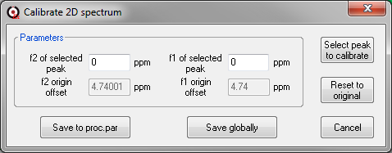

The Save to proc.par and Save globally work the same way as they did in the 1D version. Press the *Reset to original* button to zero the coordinates at the center of the spectrum.

*Note that currently this option is not available. Please reference your data using the Setup menu lock and calibrate option.*

# Running multiple experiments using the batch list

In addition to the history list, SpinsolveExpert can also display a batch list. This can contain a group of experiments and associated parameters which will be run one after the other. The batch options can be displayed by selecting the batch mode in the experiment control section of the interface.

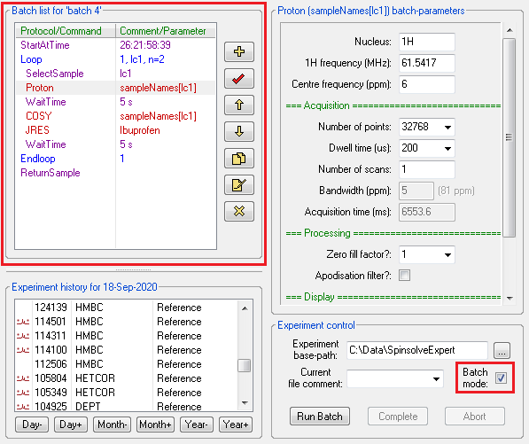

Simple experiment automation can be achieved by adding several experiments to the batch-list and then running then one after the other. Experiments are added by selecting them from the main menus as for history mode, setting the parameters and then copying them to the batch list using the plus button:



Note that if you want to change the batch parameters then they will only be copied to the highlighted batch experiment when you click the check button



The check mark will turn red if a parameter has been modified and you haven’t updated the batch entry. It is worth reviewing the parameters for each experiment before running the batch. You will also be warning if you try and load a new experiment without saving the parameters for the old one.

You can also add delays and start times. These are added from the main Batch menu (commands WaitTime and StartAtTime). Note that the comment reflects the parameter value in these cases and cannot be set independently.

Once all the experiments have been added to the list, press the *Run Batch* button to start executing the experiments.



Assuming there are no parameter errors, all experiments will be run from the start to the end of the list.

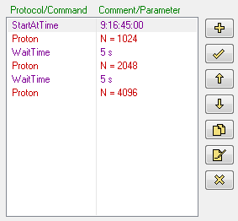

In this case the experiment will start on the 9th day of the current month at 16:45:00. Then a series of Proton experiments will be performed with different numbers of points (note the comments are just names – the number of points will need to be modified in the parameter list). A 5 second delay is added between each experiment (this can be done automatically from the Batch menu.)

The experiment comments along with the time and delay values can be set using the rename button. Multiple experiments can be selected for renaming.



You can duplicate an experiment with the following button. Again, multiple experiments can be selected for copying.



Make sure the comment does *not* include parenthesis ‘()’ as these are added automatically to the filename and extra ones can cause problems. Similarly, because the comment will become part of the experiment folder name, you should not include invalid characters as defined by Windows (these are: <, >, :, ", /, \, |, ?, *).

The output from the batch list will be appended to the history list bracketed by two dummy folders named: BatchStart and BatchEnd

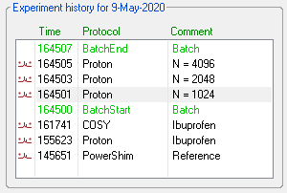

You can view the results of each batch experiment by clicking on appropriate entries in the history list.

## Organising the batch list

Experiments can be renamed, moved, duplicated and deleted within the experiment list using the buttons on the right of the experiment list. Here is the complete list of controls.

### Add experiment

 The *Add experiment* button adds the experiment currently displayed in the *Experiment parameter list.*

### Update parameters

 If the parameters for a batch experiment have been modified this button will copy the new parameters to the acqu.par file. The check mark will be red until the update has been performed.

### Delete experiment

 The *Delete experiment* button moves the selected batch experiment folder(s) to the Windows recycle bin and removes the entry from the experiment list.

### Copy experiment

 The *Copy* button makes a copy of the selected experiment(s) acquisition parameters. The copy will appear at the bottom of the batch list.

### Rename experiment

 The rename button displays a small blocking dialog window into which a new comment can be entered. The drop-down menu contains the list defined in the Samples menu.

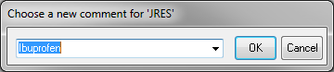

Multiple experiments selecting in the batch list by clicking on the first item and then shift-clicking to select other items (ctrl-clicking is not supported).

### Move experiment up or down

The up and down buttons move the selected experiment up and down in the list. The list order is stored in a file called expList.par which is stored at the top level of the batch folder.

## Selecting samples in the batch list

If you have a sample changer installed on your Spinsolve you can also automatically select the sample to investigate. In this way you can run the experiments on different samples without having to be present to change them.

The first thing to do is add a list of sample names from in the list in the ‘Samples’ menu:

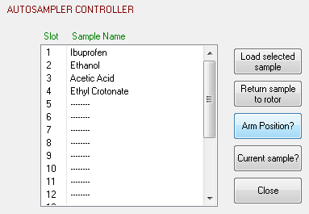

Here you can add sample names to the list by selecting the ‘Edit comment’ option from the list contextual menu or by double clicking on the entry. Press the Close button to return to the normal interface. Note that the last selected sample name will be copied to the current comment field in the ‘Experiment control’ group in the main interface.

Then in the main interface just add the *SelectSample* option from the Batch menu, select the sample name or slot number in the parameter list and press the Add (+) button to add it to the batch list.

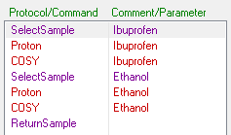

You can return the sample to the sample changer rotor with the ReturnSample command.

## Adding loops to the batch list

If you need to repeat an experiment or group of experiment several times or with different samples, you can do this by adding loops to the batch list. Loops are adding using the *Add simple loop* option in the batch list contextual menu (right click on the list). This will add a Loop and a Endloop command to the end of the list. You should move these to bracket those experiments you wish repeated.

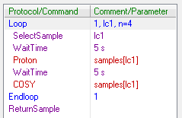

The simple loop command runs from 1 to n, in this case set to 4 using the rename comment button. The variable lc1 (loop counter 1) can be used to select the sample if added to the SelectSample parameter or in the protocol comment for other experiments. In this case 'samples' is a list of names defined using the Samples menu. This converts the loop counter into a sample name.

When you run the batch list it will run the specified experiments for each sample updating the comments in the history list to reflect the samples used.

If you need them, multiple loops can be added to the batch list. Each loop has a numerically different loop counter variable (lc1, lc2 etc). Loops can also be nested.

Also, if the automatic sample changer has empty slots you can use the array loop command. This allows certain slots to be chosen e.g. to choose slots 1,3,5,7,9 you would enter



Finally, if you don’t have an autosampler than the SelectSample command will just prompt you to manually change the sample.

## Modifying parameters in loops

Note that it is currently not possible to modify a batch file’s parameters using the loop index. If you wish to run an experiment in ‘array’ mode i.e. Step through a series of values for a parameter, you should use the ArrayExperiment script. This can also be added to a batch list. See section 4 for more details.

## Batch timing

By default, batch experiments perform a complete repetition time and don’t finish early as is the case in history mode on the last scan. This means that it is not necessary to place delays between experiments in a batch list. The only exception to this might be the first experiment and if samples are changed automatically within the batch list.

## Adding items to a batch list while it is running

From version 2.02 is an experimental option it included to allow experiments to be added to a batch list while the experiments are already running. This cannot be done in the working version of Expert since the interface is largely disabled during this time. However, in the Expert viewer you can make changes. Just open the viewer and select the batch view mode. Then add the experiments you want to the end of the list. Do not attempt to move the added experiments before the currently executing experiment or inside a loop. Currently there is no check for this, and it may cause unexpected behaviour. When the working version of Expert has completed the current experiment, the added experiments will be appear into the working batch list.

# Automation using a script

In addition to the batch scripts, SpinsolveExpert provides a more sophisticated way of controlling existing experiments. Automation scripts provide the freedom to modify parameters, have loops or tests, display the data in different ways, or apply non-standard processing.

Automation scripts use the underlying Prospa interpreted scripting language, which has a syntax a little like Matlab. This allows the manipulates a variety of data types, such as lists, structures, vectors and matrices as well as special commands for displaying some of these objects. It also contains the usual control structures (for-next loops, if, elseif statements etc.) typical in most programming languages. Please refer to the Prospa programming guide for more information.

To allow the Automation script to access existing experiments, several special commands are required, the primary one being RunExpt (run experiment).

## Running a simple script

Start by opening the script editor with a basic script template already loaded. Do this by selecting the option *Edit script template* from the Scripts menu. This will open a copy of the script template file. You should first save this into a suitable folder which should be outside the Prospa install directory.

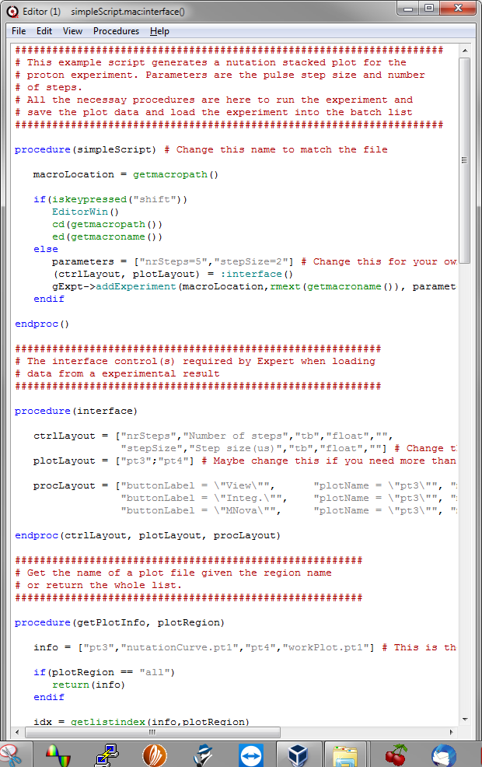

The script is divided into several *procedures* which are like functions in other languages. The first string after the procedure command is the name of the procedure, any additional strings are arguments passed to the procedure. i.e.

procedure(name_of_procedure, argument1, argument2 ...)

body of procedure

endproc()

The procedure ends with the *endproc* command which also functions to return any values to the calling program (none in this example)

In the simpleScript file or macro (extension is .mac) are four procedures:

* simpleScript ... this is the entry point to the script, and this is the procedure run when you select the script from a menu entry. The default action is to add the script to the experimental parameter interface. If the shift key is held down when the script is selected from the menu, the script will be loaded into an editor.
* interface ... This defines the parameters which will appear in the parameter list, the layout of plots and the post processing controls which should appear in addition to the defaults.
* getPlotInfo ... associates filenames with different plots so the program knows where to save plots at the end of an experiment and which files to load into which plots when reloading an experiment.
* backdoor ... this is the core of the experiment code which calls the relevant experiment or experiments.

There may also be a few other procedures – these are optional:

* addCommand ... this will override the default add command to add the script to the batch list (see SelectSample)
* renameCommand ... this will override the default rename procedure in case the comment has special syntax which needs checking (e.g. WaitTime and StartAtTime commands).
* parameterChanged … this will change the comment in the batch list when it is modified in the parameter list (see for example SelectSample in the batch menu).
* expectedDuration … this returns the expected duration of the script in milliseconds. This ensures that the progress bar will work. A negative duration will cause the progress bar to cycle continuously using the magnitude of the duration for one pass. (This is used in the StandbyShim protocol)
* onLoad … this overrides the normal loading of data and can be used for example to combine several data sets together to display a result (see the script RepeatedExperiment) or load the FID and calculate the spectrum if it hasn't been stored.

We will start by looking at the backdoor procedure, which in this case implements a simple 1-pulse pulse duration sweep command. This procedure performs the following steps:

1. It makes all parameters available to the procedure.
2. It defines the plot layout.
3. It allocates memory for the collected data.
4. It loops over the M pulse-length steps.
5. It calls the Proton experiment changing the pulse length each time.
6. It plots the data.
7. When finished it saves the data.

Looking at these steps in more details

procedure(backdoor, parameters)

assignstruct(parameters)

(pt1,pt2,pt3,pt4) = InitPlot(["pt1","pt2";"pt3","pt4"])

M = nrSteps

mt = cmatrix(16384,M) # Time domain data

mf = cmatrix(16384,M) # Freq domain data

The backdoor procedure is called when the Run button is pressed in the main interface. The parameters are those defined in the interface procedure after the user has had a chance to enter sensible values. The parameters are in the form of a Prospa structure.

The assignstruct command takes this structure and converts it to individual local parameters. So in this case it takes parameters->nrSteps and parameters->stepSize and converts them to two new parameters nrSteps and stepSize.

The InitPlot command organises the plot with two plots in the first row and the two in the second row. (See appendix 2 for details of the plot layout syntax). It returns 4 values which are references to the indivdual plots.

Two complex matrices are defined with 16k colums and M (nrSteps) rows to hold the time and frequency domain data. Note that Prospa defines its matrix coordinates as (x,y) not (row, column) as in Matlab or numpy in Python.

Then *M*, Proton experiments are run.



Each experiment has a pulse length equal to 1 plus the loop counter k, all multiplied by the stepSize parameter. So the pulse length will range from stepSize to *M\**stepSize microseconds. A number of other parameters such as the number of points, repetition time and dwellt time are defined. Intially we do not save the data.

(result,acqPar) = RunExpt("Proton",

["nrPnts = 16384",

"repTime = 1000",

"nrScans = 1",

"dwellTime = 100",

"pulseLength1H = $(k+1)*stepSize$",

"saveData=\"false\""])

The RunExperiment command has as its first argument the name of the experiment to run (Proton in this case), while the second argument is a list of parameters to set. All other parameters will take their default or common values. Once the experiment has completed it will return a structure result containing the time and frequency domain data sets. These are stored in the kth row of the time and frequency matrices defined previously.

mt[~,k] = result->tData

mf[~,k] = result->fData

We then display the data in matrix *m* using the StackedPlot command. This process is repeated for all *M* scans.

StackedPlot(pt3, mf, k, xRange, result->fAxis,

usePPM, [1:M]*stepSize, "linear",

"Frequency (ppm)",

"Pulse length (\G(m)s)",

"Experiment = $k+1$")

The xrange and usePPM parameters have been extracted from the acqu.par file defined by the Proton experiment.

xRange = [acqPar->dispRangeMinPPM,acqPar->dispRangeMaxPPM]

usePPM = acqPar->usePPMScale

Once the M scans have been completed, the data is saved. In addition to the stacked plot (in pt3) we also save the time domain matrix mt so we can import the data to Mnova as a stacked plot. The acqusition parameter file acqu.par is also saved after adding the additional parameters nrSteps and stepSize.

acqPar->saveData = "true"

par = mergelists(list(acqPar),list(parameters))

ucsFiles:saveAcquPar(par)

ucsFiles:savePlot(pt3,:getPlotInfo("pt3"),par)

ucsFiles:saveMNovaData(mt,"data.2d",par)

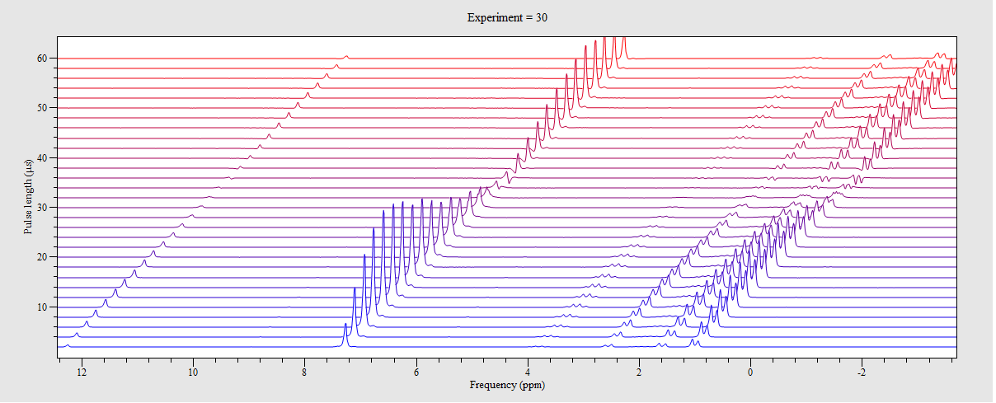

*The output from this script for an Ibuprofen sample with 30 steps and a step size of 2 us.*

To learn more about the syntax of the special commands like *InitPlot*, *RunExpt* and *StackedPlot* control double-click on the command to see the script. Built-in Prospa commands like *mergelists* or *getsublist* can be investigated by clicking on the command and pressing F1.

The final plot pt4 is used for displaying integrals which may be calculated using the post processing buttons. In this case 3 peaks at 12.2, 7.26 and 0.98 ppm have been integrated.

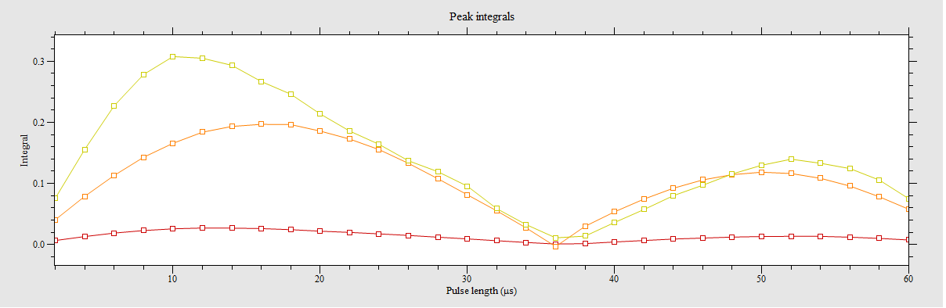

The early peaking of the 7.26 (Chloroform) curve suggests that the repetition time was too short.

## Adding the script to the main menu

Once the script has been written, save it to a suitable folder outside the Prospa install directory. Then drag this folder to the main menu bar. It will be added to the end of the list of experiments. You can modify the menu name by selecting the ‘Open SpinsolveExpert preferences’ option in the main menu. Press the 'Experiment Menus' button to open the following dialog:

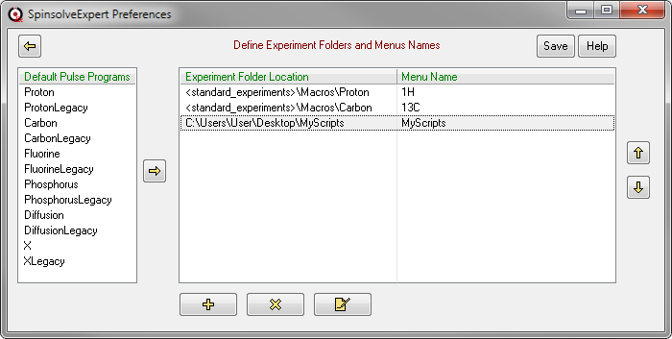

In addition to changing the menu names by pressing the *rename* button



or double clicking on the selected menu item, you can also add new menus from the default pulse program list by selecting one and pressing the *right* arrow button



You can add entries from outside Prospa by using the *add* button



This is an alternative to the drag and drop option mentioned above (you can also drag and drop onto this window).

You can remove the selected entry from the list with the *remove* button



Or reorder the menu items using the *up* and *down* arrow buttons



Once you are finished modifying the new menus press the *Save* button to update the menu and save this information to the preferences folder in the macro ‘pulseProgramMenus.mac’.

## The ArrayedExperiment script

From V2.02 a versatile new script has been added called ArrayedExperiment. This allows any experiment to be repeated with a parameter being stepped between each repetition. An array of numbers can be provided to specify the parameter values which should be used.

In the following example a Proton experiment is run with the pulseLength1H parameter being changed from 2 to 20 us in 2 us steps.

The result is a stacked plot from which can then be loaded into the 1D. The peaks can then be integrated to find the 90-degree pulse length.

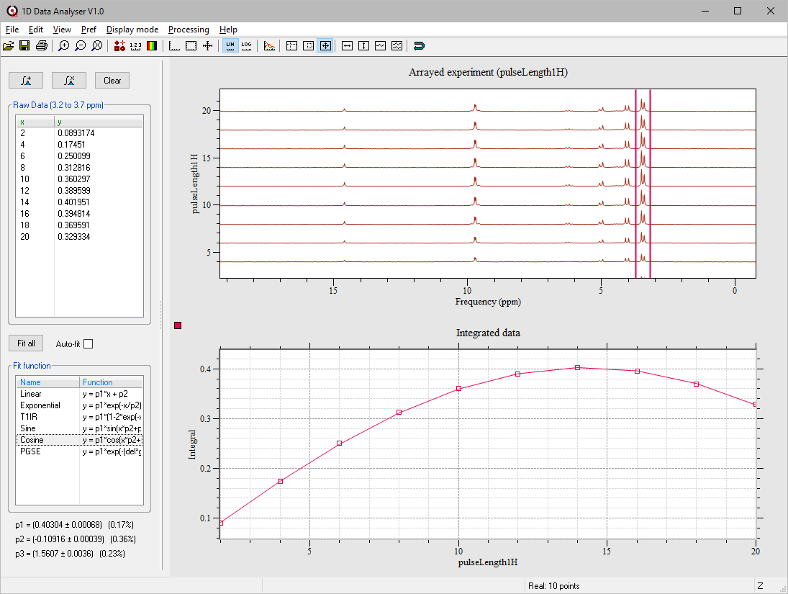

# Getting further help

For more information about menu items please refer to the documentation accessible from the Macro help button at the top of each menu.

More information about pulse programming can be found in the main Help menu under 'View programming guide'.

More information about Prospa programming can be found in the PDF documentation folder within the Prospa installation folder.

# Data storage

There are two ways of saving data in SpinsolveExpert – the date hierarchy mode and the flat mode.

## Date Hierarchy Mode

As data sets are collected by the program they will be stored in a folder of their own. The folder name will contain a date stamp (yymmdd), a time stamp (hhmmss), the protocol name and a comment in parentheses. Each experiment folder is stored below a date-based hierarchy of folders which is itself beneath the Experiment base path. For example

C:\Data\SpinsolveExpert\2020\05\09\200509-145651 PowerShim (Reference)

In this case the path in red is the experiment base path. The blue path is the date hierarchy and purplepath is the experiment folder.

Only experiments in a single day are visible at one time, but by navigating to a different day you can select different days to view. Note that if you add a new experiment the display will automatically jump back to the current day.

## Flat Mode

In this mode all accessible data is in the current experiment base-path regardless of the date. In this case the history list will also display the date for each file as well as the time stamp. This mode should be used sparingly as it will become very large in a short time.

C:\Data\SpinsolveExpert\200509-145651 PowerShim (Reference)

However, it is useful when viewing data which has been exported using the Search History option in the main File menu. You can also copy data from a flat folder back into the date hierarchy folders using the '*Import SpinsolveExpert data folders*' option in the file menu.

## Data Folder Format

Inside each data folder is the acquisition parameter file which contains the parameters used to run the experiment, the collected data in pt1 file (Prospa 1D plots) or data.1d (MNova compatible data files) as well as a processing parameter file.

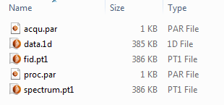

Other files may be present if additional processing is done. If a file acqu.par.bak file is present then this is the acqu.par file before the MNova compatible data is written out. In this case acqu.par has additional parameters required by MNova.

A folder called ppCode may also be present. This is a copy of the pulse program scripts. This is useful as a backup for modified or user defined experiments which may not be available in the default installation.

# Plot layout syntax

Plot layouts are used in a number of places within the SpinsolveExpert software. They determine which plots are displayed and how they are organised, both when the experiment is run for the first time and when the resultant data is subsequently reloaded.

Layouts are described by a 2D Prospa string list object. Each row in the 2D list describes a row of plots. Each entry in the row names a plot and the position in the list determines the position of the plot in the user interface. The format for the simple list is shown here:

["plot11Name", "plot12Name" ... ;

"plot21Name", "plot22Name" ...]

In this case the numbers in the names refer to the row and column the plot appears in. The end of row character is a semicolon ';'. Valid plot/image names are:

ptx where x is 1,2...6 (Displays a 1D x-y type plot)

imx where x is 1,2..4 (Displays a 2D intensity or contour image)

The plot widths and positions will be determined based on the number of plots per row and their row position. An example with 3 plots in the first row and an image and a plot in the second would be:

["pt1","pt2","pt3";

"im1","pt4"]

Which will appear like this in the user interface:

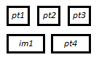

The semicolon is also used to separate rows in Prospa 2D numerical matrices and structure arrays.

If you only have a single plot to display, then you will need the listto2d command to convert the list type from 1D to 2D. e.g. listto2d(["pt1"])

## Defining plot layout in Experiment scripts

In normal Experiments the plot layout is defined in the User Interface Tab. Here there are two procedures; *plot_run_layout* which defines the plots to be visible when running an experiment and *plot_load_layout* which defines the plots when loading precollected data. The system applies these layouts before the Experiment Control macros procedures are called.

## Defining plot layout in automation scripts

In automation scripts the plot *run* layout is defined using the *InitPlot* command. E.g. InitPlot(["pt1","pt2";"pt3"]). This should be done before running an experiment using *RunExpt*. The *plotLayout* parameter passed back in the script interface procedure defines the plot *load* layout.

# Post processing button layout structures

The organisation of the post processing buttons for each experiment is controlled by the procedure *processing_controls* found in the *User Interface* tab of normal experiments, or in *interface* procedures of scripts. This can be a 2D string list or a structure array. The latter is a more recent introduction and is more readable. The following shows the layout for the simpleScript example described in section 4. First using a 2D string list:

procLayout = ["buttonLabel = \"View\"",

"plotName = \"pt3\"",

"macroToRun = \"StackedPlotSetup()\"";

"buttonLabel = \"Integ.\"",

"plotName = \"pt3\"",

"macroToRun = \"IntegrateRegions()\"";

"buttonLabel = \"MNova\"",

"plotName = \"pt3\"",

"macroToRun = \"exportMNova2D(\\\"pt3\\\")\""]

Here each entry consists at a minimum of a button-label, the selected plot for this button and a macro to run when it is clicked. There can also be other parameters such as tooltips and button icons. Each button description is delimited by a semicolon. The need to quote each item in the list makes for a confusing array of quotes, since quotes inside quotes need to be escaped with a back-slash and doubly if inside that.

The structure array option removes one level of quoting making the layout easier to read and debug:

procLayout = struct(buttonLabel = "View",

plotName = "pt3",

macroToRun = "StackedPlotSetup()";

buttonLabel = "Integ.",

plotName = "pt3",

macroToRun = "IntegrateRegions()";

buttonLabel = "MNova",

plotName = "pt3",

macroToRun = "exportMNova2D(\"pt3\")")

Access to items in the structure array is also a lot clearer e.g

pr procLayout[1]->buttonLabel

Integ.

Compared to

pr getlistvalue(procLayout[~,1],"buttonLabel")

Integ.

Also, all items in a list are strings, whereas in structures they can be any data type.

# Software installation and obtaining a license

## Downloading the SpinsolveExpert software

Apart from the standard Spinsolve software all Magritek products use the Prospa software package with a script layer above it to allow it to interface to the relevant spectrometer. The SpinsolveExpert version of this software can be downloaded by requesting a box.com link. Just email [support@magritek.com](mailto:support@magritek.com) giving details of your system.

## Installation

Once you have downloaded the installer, double click on it to start the installation process. *Note that if you want to install the software outside your user area (e.g. in C:\Program Files (x86)) you will need to have administrator login rights and run the installer as administrator.*

Start by agreeing to the license terms:

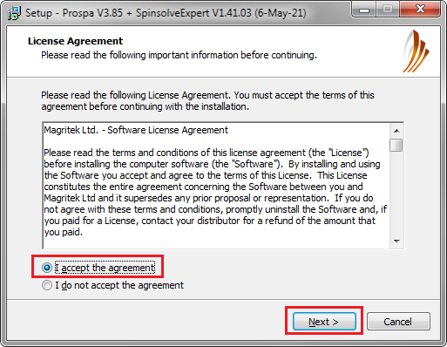

Next choose an installation location.

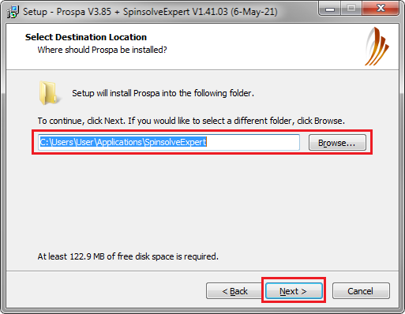

For a single-user the recommended installation location is in your home folder in a subfolder called Applications. e.g.

C:\Users\user_name\Applications\SpinsolveExpert

For a multi-user environment

C:\Program Files (x86)\SpinsolveExpert

Next you can choose to create a desktop shortcut. This is useful since SpinsolveExpert needs to access a script file to startup and the short-cut takes care of this. However, you can regenerate this shortcut after installation using the option in the main file menu.

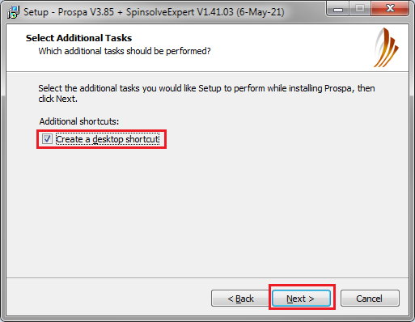

Next review the location and press the install button:

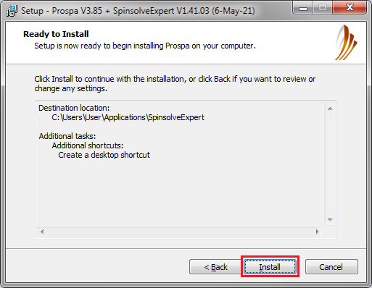

Once the installation is complete you will be offered several options. The first screen describes these.. If this is the first time the software has been installed, you should check the Install the USB Driver option. You should *not* have the Spinsolve connected at this stage.

You should also check the Launch SpinsolveExpert option.

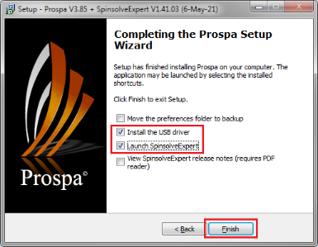

When the driver has been installed the software will start. If you don't have a license, you will see this dialog:

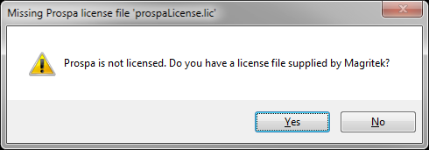

If you have a license file place it on the computer's desktop and answer 'Yes' to this question and follow the prompts to copy the license to the Prospa installation folder. If you don't have a license, then answer 'No' and a license request file will be generated and saved to the desktop. Please send this file to [support@magritek.com](mailto:support@magritek.com) asking for a Prospa license for SpinsolveExpert. Be sure to include your name and affiliation in the email.

Any questions about using SpinsolveExpert or Prospa can be directed to [support@magritek.com](mailto:support@magritek.com).

# Problems running SpinsolveExpert

## Missing desktop icon

SpinsolveExpert is simply a user interface built on top of the Prospa application. The desktop shortcut allows you to automatically run Prospa with this user interface without displaying the default Prospa interface. However, if the SpinsolveExpert desktop icon has been deleted, you can regenerate it in the following way:

1. Navigate to the Prospa installation folder (typically C:\Users\UserName\Applications\SpinsolveExpert).
2. Start the application Prospa.exe
3. In the Prospa layout menu choose SpinsolveExpert.
4. When SpinsolveExpert opens choose the option *Make a desktop shortcut* from the File menu.

## SpinsolveExpert user interface does not appear

If the SpinsolveExpert interface does not appear when selecting the desktop icon but the Prospa application is seen running in the task manager, it is probably because one of the SpinsolveExpert preference files has been corrupted. This can happen if the computer is suddenly shutdown while Expert is running (e.g. because of an unscheduled power cut or Windows update).

To solve this problem, you need to either delete or repair the damaged preferences file. These files are stored in the folder

C:\Users\UserName\AppData\Roaming\Prospa

This is normally a hidden folder, but you can access it by typing:

%appdata%\Prospa\

into the address bar of a File Explorer window.

Inside the folder

C:\Users\UserName\AppData\Roaming\Prospa\Preferences V3.4\SpinsolveParametersfolder

is a file called *Expert2Interface.par*. Delete this and restart SpinsolveExpert. If this doesn’t work, try deleting or renaming the whole Prospa folder in the Roaming directory. (Note that versions of Expert from 1.41.0 onwards should ignore corrupted *Expert2Interface.par* parameter files so this is unlikely to cause this problem.)

## The user interface is unresponsive

This can happen if there is a scripting bug in an experiment which prevents Expert from exiting the code correctly. This is a common problem while developing a new experiment. You can often resolve this by restoring the interface with the restore button in the View group of controls.

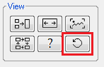

If this doesn’t work, try disconnecting and reconnecting the Spinsolve USB cable. If the interface still doesn’t respond you will need to shut Expert down via the task manager. (Look for the Prospa process).

Sometimes the Spinsolve can be left in an odd state which prevents experiments from running. In this case you will need to cycle the power on the spectrometer. Once restarting reload the shims using the *Load Expert or User Shim* option in the Setup menu and then run *Lock and Calibrate.*